Continuous Assessment Exam I
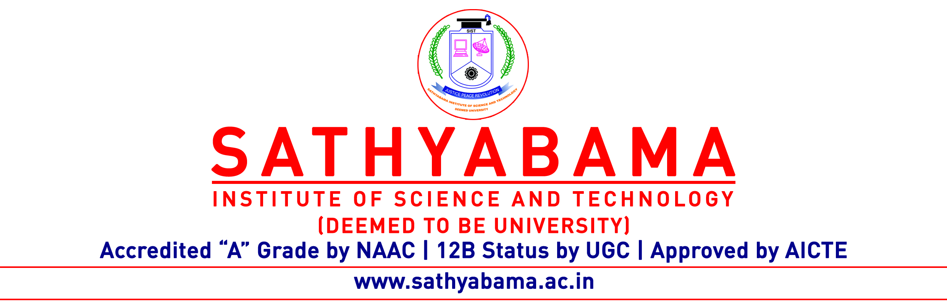
Program :BE Max. Marks : 30
Course : CSE Time : 1 Hour
Course code : SCSA1602 Sem :VI
Batch : 2019-2023 Date : 31.1.2022
Part-A Answer ALL the questions (5×2=10)

Q.No | Questions | CO (L)
 | Compare Active attack and passive attack. | CO1(L2)
 | Find the ciphertext for the plaintext “instruments” with the keyword “monarchy” using Playfair cipher. | CO1(L1)
 | What is steganography? | CO1(L1)
 | Outline the strength of DES. | CO2(L2)
 | Illustrate the end to end encryption with neat diagram. | CO2(L2)

Part-B Answer ALL the questions (2×10=20)

Q.No | Questions | CO (L)
 | Explain the model for network security with neat diagram | CO1(L2)
 | (OR)
 | Show the ciphertext for the plaintext ” meet rk” using hill cipher.  Assume k= 2 5  4 7 | CO1(L2)

 | What is DES? Elaborate the working of DES with necessary diagrams. | CO2(L2)
 | (OR)
 | What is random number. Explain Blum Blum shub generator with example | CO2(L2)

